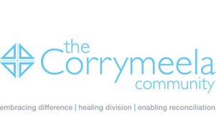
Corrymeela GB Conference

WHEN - Saturday 24th November 2012, 10.00am for10.30am – 4.30pm
WHERE - The Reading Quaker Meeting House, 2 Church Street, Reading, RG1 2SB

Registration form for Faith and Identity – Embracing Difference

Please complete this form and either send:-

by e-mail * to Mick Oliver at micksheila67@hotmail.com
or
by post marked for the attention Mick Oliver and marked “Corrymeela Conference” to
19 Woodcroft Avenue, Stanmore, Middlesex, HA7 3PT. Please include the conference fee of £25.00 made payable to “Corrymeela Community”

N.B. * It is possible for those registering by e-mail to pay by cheque on the day of the conference.

Name/s: ____________________________________________________________

Address (including postcode): ___________________________________________________________________________
__________________________________________________________________________________________________________________________

E-mail______________________________________________________________________

Tel. No._____________________________________________

Any special dietary requests:_______________________________________________________________________________________________________________________________________________________________________________________________________________________

I/we* wish to reserve ........ places(s*) at the Corrymeela Friends Conference to be held on 24th November 2012 at The Reading Quaker Meeting House, 2 Church Street, Reading, RG1 2SB

- Delete as appropriate

